12 Best Things to Do in Santa Fe, New Mexico
By: AuthorNoreen Kompanik
Posted on Last updated: May 26, 2022

Early Native Americans called Santa Fe the “Dancing Ground of the Sun.” Founding frontiersman referred to it as “The City Different.” But what is it that truly sets this city apart from others within the continental U.S.?
Many believe it’s Santa Fe’s living history. As the oldest state capital in the country, it’s built on Tewa Puebloan land and fully embraces its Native American cultural roots. Legendary history and culture abound in every corner of the city.
Anyone who’s spent time in Santa Fe will tell you that this Southwestern gem has a unique and unforgettable vibe. Though it may be New Mexico’s capital city, it exudes much more of a small-town feel. Its iconic adobe and pueblo-style architecture are second-to-none. Add in its rich history, world-class art galleries, charming inns, alluring markets, authentic cuisine, and wide-open spaces and you have a spirited town that celebrates its culture and heritage in an impressive way.
There’s a lot to see, do, and experience here. Here are some of our top recommendations for a truly enjoyable time here.

The 12 Best Things to Do in Santa Fe, New Mexico

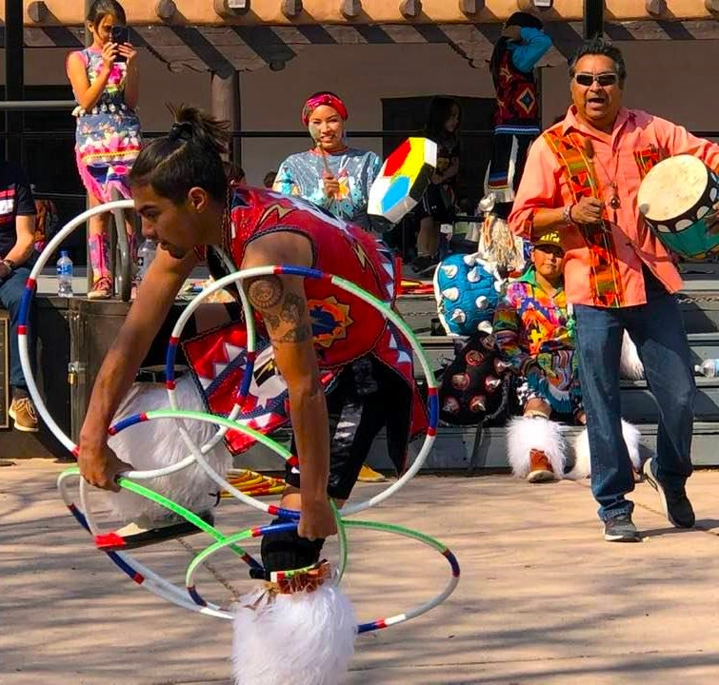

Watch Lightning Boy Foundation on the Plaza
No matter what visitors to the Santa Fe Plaza are doing, they stop on a dime and gather in the center of the plaza for a performance of artistry in motion by the hoop dancers of the Lightning Boy Foundation. This group was established to nurture and build confidence and integrity in its young Native Americans through the artistic expression of their magnificent cultures.
The foundation was named for “Lightning Boy” Valentino Tzigiwhaeno Rivera, a young, enthusiastic, and extremely talented hoop dancer who died from a spinal cord and brain injury sustained in a car accident.

Many tribal groups across North America used the hoop in traditional healing ceremonies and have long regarded these hoops as sacred. Here, young artists tell the story with native costumes and a multitude of colorful circles that weave tales about life connectedness through the use of symbols.
There’s nothing like it. And you’ll find yourself like many others in the crowd asking, “How do they do that?”

