SFR Digital-ish Picks—Week of May 5

Lightning Boy Foundation hoops it up, SAINTS BALL are a drag, DJ Pygar exits the time/space continuum and a whole bunch of audio nerds
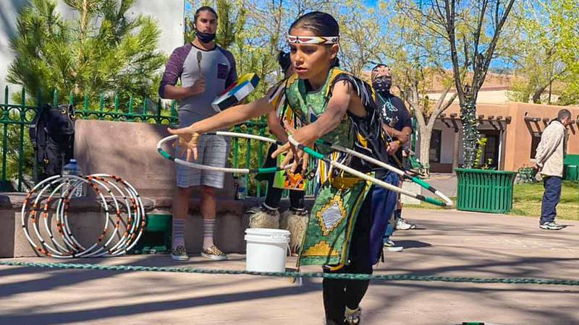

Picks (Felicia Rosacker-Rivera)
By Alex De VoreMay 05, 2021 at 12:00 am MDT

Back in Action
Hoop dancers from Lightning Boy Foundation return to the Plaza
“This [pandemic] has been harder for our kids than I’ve ever seen or experienced,” Felicia Rosacker-Rivera, director of the Lightning Boy Foundation, tells SFR. “We had to do Zoom classes with most kids the past year, and the kids always have Zoom fatigue after school. A lot of this past year has had to be dancers doing their own thing and keeping us updated.”
Despite the difficulties, including how Indigenous communities have been hit disproportionately hard by COVID-19, the organization’s upcoming performances on the Plaza and elsewhere herald a positive point for the youth dancers—albeit a masked and socially distant one.
The Lightning Boy Foundation focuses on traditional hoop dancing and tribal youth, with dancers and instructors mostly hailing from Northern New Mexico pueblos. The organization began in 2017, following the untimely 2016 death of Rosacker-Rivera’s son, Valentino Tzigiwhaeno “Lightning” Rivera (Tzigiwhaeno, Valentino’s Tewa name, means lightning) at 8 years old.
“It was originally a healing ceremony, not performance, and the ceremonies were performed with willow hoops,” Rosacker-Rivera explains. “Nowadays the dancers use PVC pipe. We still try to approach [the dance] for its traditional healing purposes.”
According to Rosacker-Rivera, the emphasis on various Indigenous traditions helps youth form a better understanding of themselves and the cultures they inhabit, as well as those around them.
“For the kids, having that community is very important,” Rosacker-Rivera continues. “We’ve got tribal youth from a lot of areas, from the Navajo tribe and one from the Mohawk tribe of New York State. This is how they can connect with each other.”
Dancers from the Lightning Boy Foundation perform on the Plaza on Saturdays and Sundays from 3-5 pm this summer, in addition to recurring biweekly performances at the Ojo Santa Fe Spa Resort. The organization was also one of the recipients of the 2021 Mayor’s Excellence in the Arts Award.
Rosacker-Rivera hopes those who attend will leave with a deeper understanding of hoop dancing traditions, as well as why its proponents continue the age-old practice.
“I always love it when we get a big crowd,” she says. “I hope people come out and try to get a new perspective on Native American dancing. Come out and see what our kids can do.” (Riley Gardner)
Lightning Boy Plaza Hoop Dancing: 3-5pm, Saturdays, May 8 and Sunday May 9. Free (donations encouraged) Santa Fe Plaza, 163 Lincoln Ave. lightningboyfoundation.com

